ECA3101-NANO ELECTRONICS
Exp. 2. Simulation of Density of States of Quantum Well Structure with Various Nano-meter Thickness
TEST CASE-1: Material thickness is 0.2nm
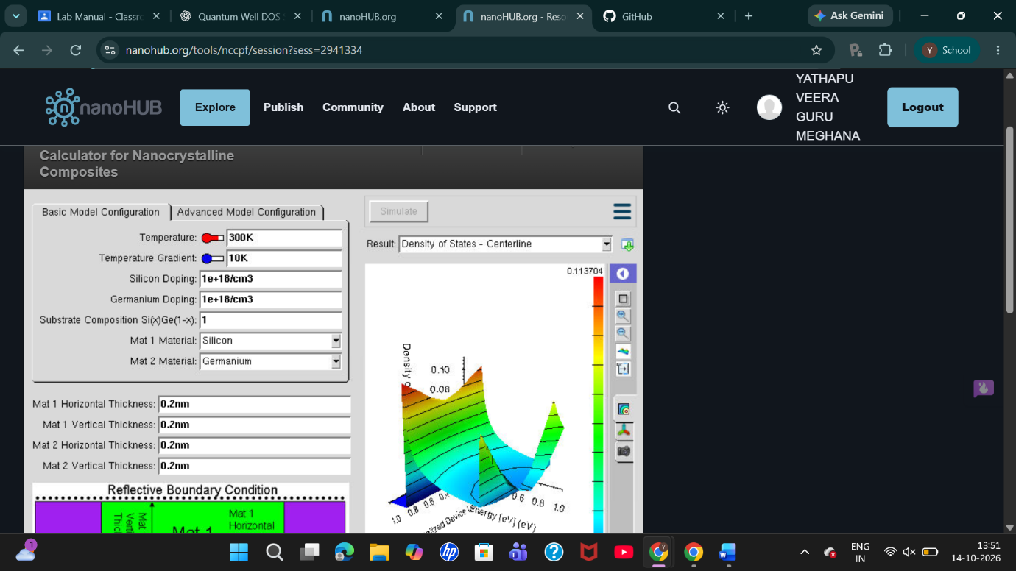
TEST CASE-2: Material thickness is 0.5nm
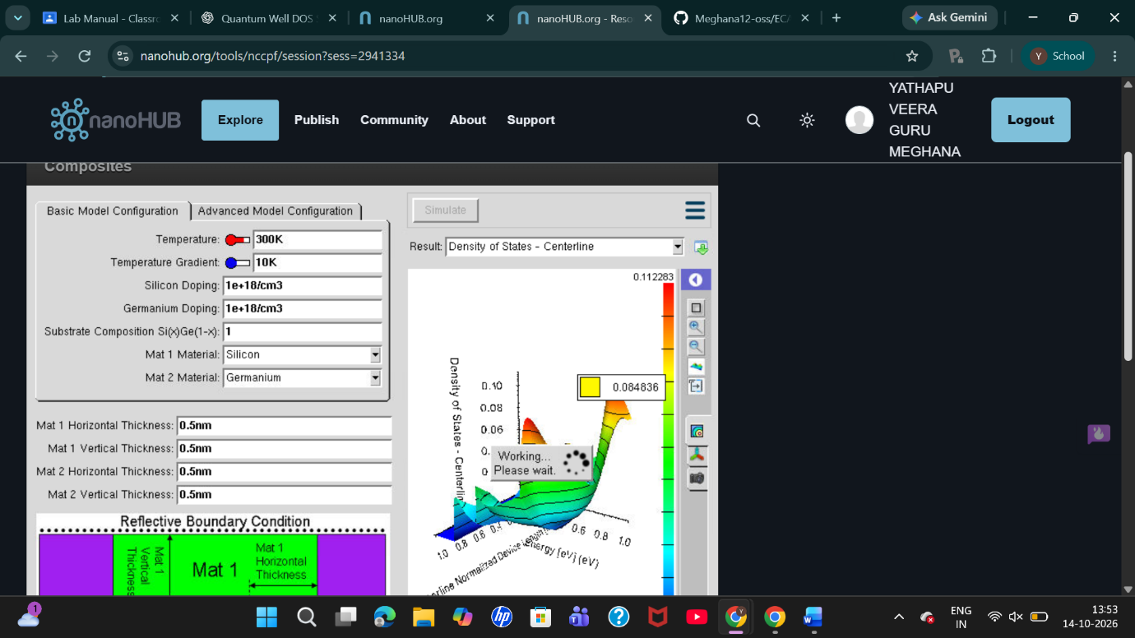

TEST CASE-3: Material thickness is 0.6nm
